Hi Team,
Happy New Year! I have created a quick website for the job seeker profile here from an existing template of a website – see how crisp it looks - https://ry72n.weblium.site/. Again, wanted us to get inspiration from this style (the look and feel ) and make our site look crisp. PLEASE UNDERSTAND THE IMPORTANCE OF KEEPING IT CRISP - a reason why I have been asking for UX expertise to help Prithwiraj and cadence calls to catch errors when they happen.
As there has been no demo of the software and I find some of the buttons/layouts/workflows somewhat non-intuitive. Again, the developers had started with some great ideas but I couldn’t figure out some of the workflows. Hence, it is even more important to realize the need to make UI simple and attractive. I find myself correcting some of the basic UX mistakes without even getting into the innovative aspects of the website.
EMPLOYER
- If I don’t log in and click on “employers” or “job seekers” or” experts” it should not say “list of …” as the headline in the banner. DONE
- Also when I click on “job seekers” it should have “New role?” button instead of “Post jobs”
DONE
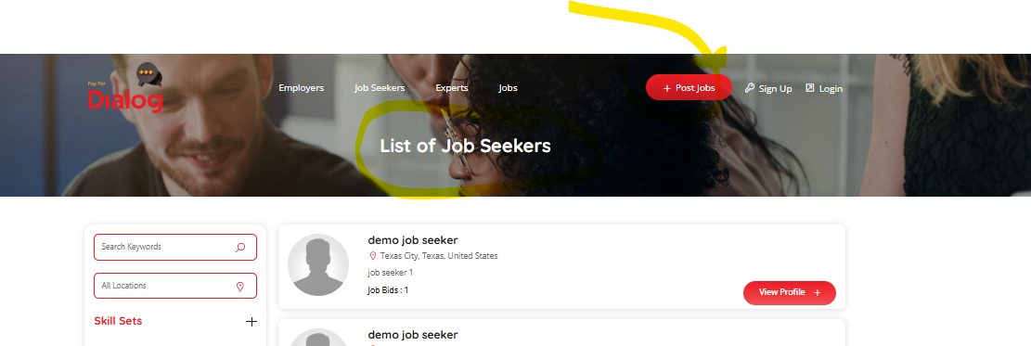
I signed in as the employer.
- Can we rename “my jobs” to my “job posts” in the tab DONE
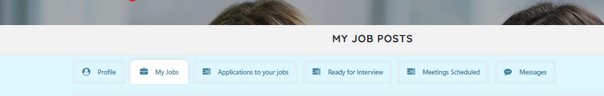
I posted a new job and a new screen came up
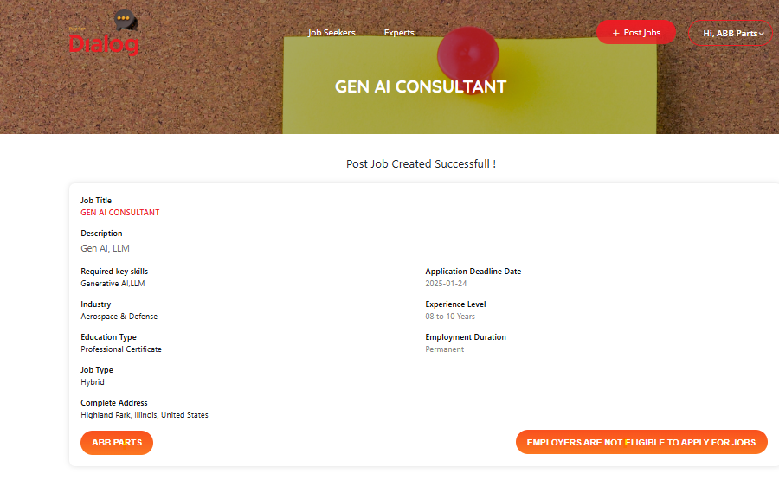
- Can we make this page look similar to the page where I entered about the job? DONE
- Also there should be a back page to take me to the jobs the employer posted DONE
- Also the two orange ovals can be removed – the company’s name can be mentioned on the right. DONE
- When I deleted a job, it took a little while to reflect that. DONE
- Please keep the tab color consistent – no need to make it red. DONE
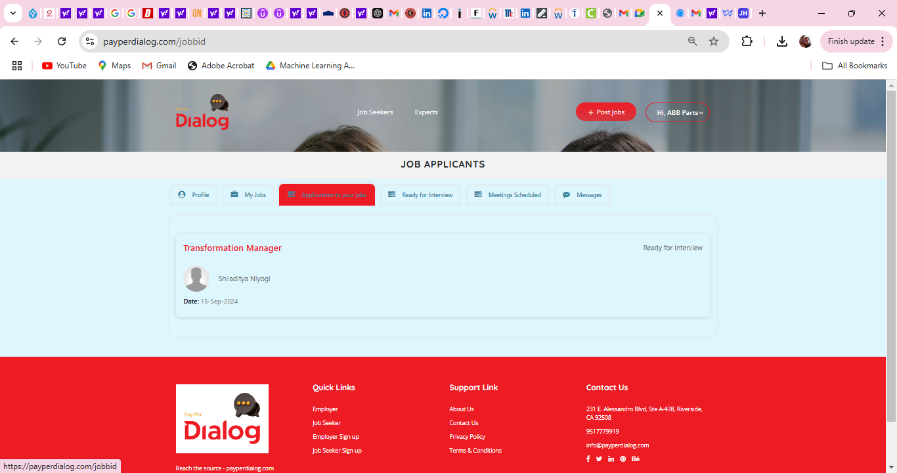
Based on the job requirements,
- Can we get a select list of candidates, right when we post a job, under “recommended employee”?
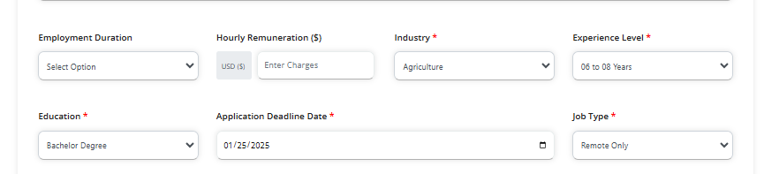
- This is where these filters should show the recommended employee; at this point it is blank:
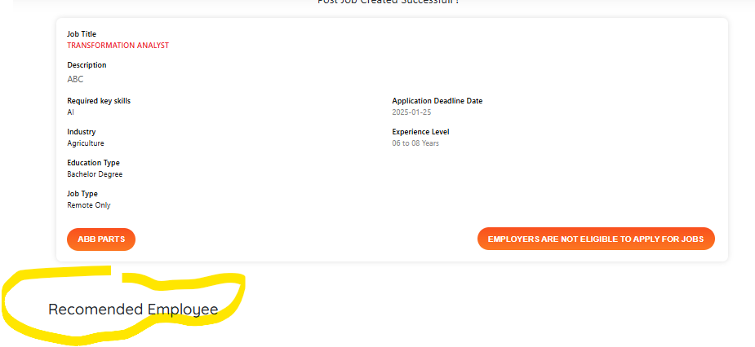
- Next to the Recommended job seekers list, should be rank based on the match.
- Also, the top ranked (or top 10) employees should have the chat and ready to interview buttons enabled as we want the employers to choose candidates too and not just depend on the applicants. There may be cases where no applicant meets the criteria of what the employers are looking for so they search in the pool. The search for candidates should also behave identically (top search results should have the chat and ready to interview buttons enabled.
- Again, after posting the job, I cannot go back intuitively to my dashboard, so there should be a “back to dashboard” hyperlink or button there. DONE
- No need of “Employers are not eligible for jobs” button. The company name should come in as a field at the top and not as a button. DONE
- As I “screen out” a candidate, I see the legal disclaimer – which is important only when I sign up as a job seeker or an employer or expert. So, no need to show the disclaimer pop up. DONE
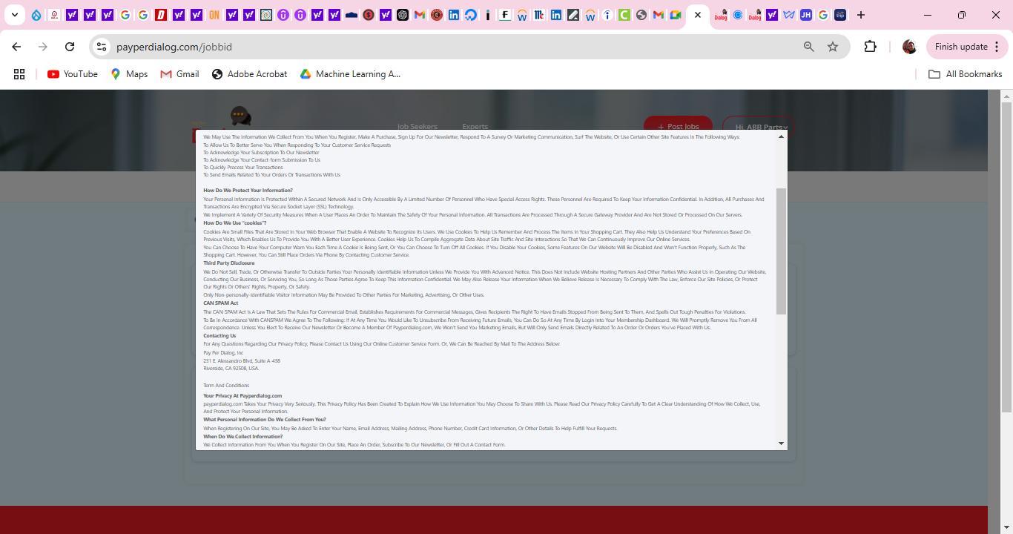
- Also the employer dashboard page should have more blocks of metrics/KPI’s –interviews conducted, time saved, average cost of interviews, payments made, as well as links to the account for the employer. The dashboard should also be a menu item.
- We should add an Account page for the employer, where we have details on the subscription, payment information, discontinue subscription, name/contact of admin, etc. The Dashboard can have a portion dedicated to this account type thing but it is more organized to have a separate page, and that is reflected as an item in the side menu.
- When I click on the “ready for interview” option, I get a similar legal disclaimer. Can we include the fact that the employer has to pay the hourly rate at a minimum and that will be made from the payment information in the account. DONE
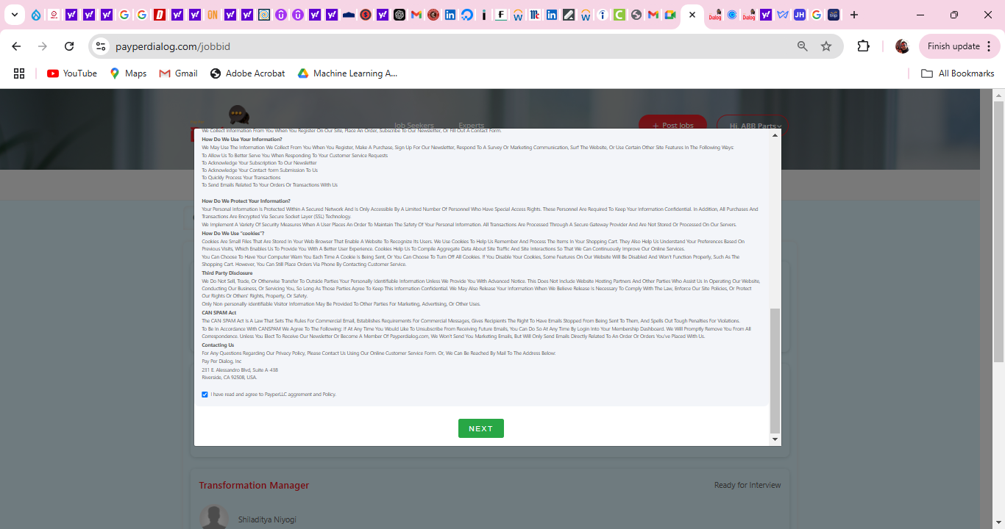
- When I clicked on the Ready for Interview button, without filtering by post, I saw only one:
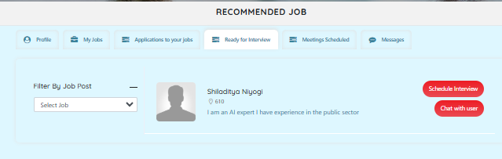
- However, when I clicked on the dropdown and selected one of the jobs, it showed me the relevant one:
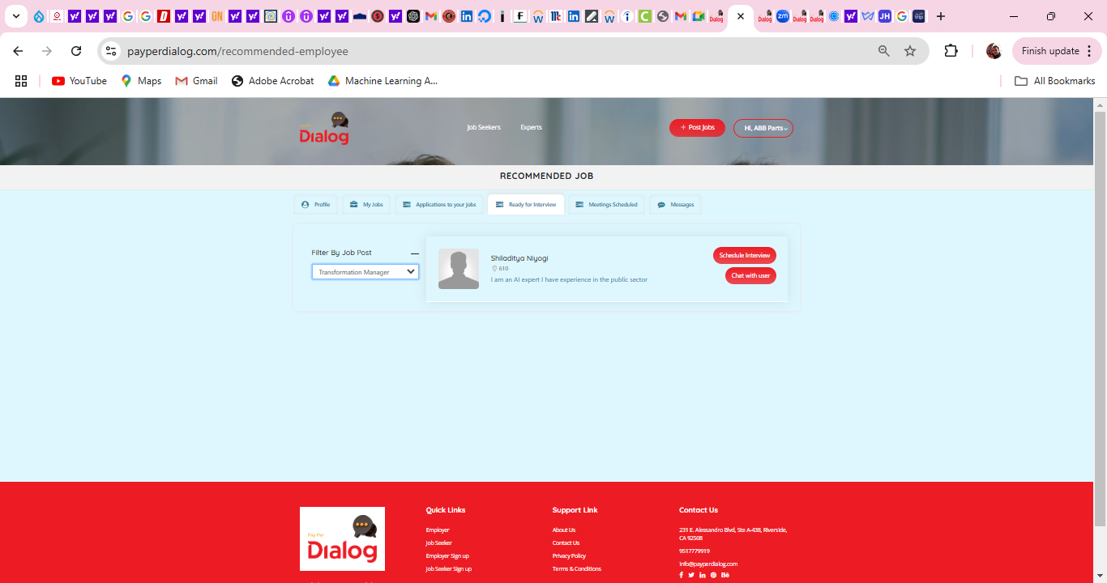
- However, when I unselected that I now see my two applications. So that was an anomaly. DONE
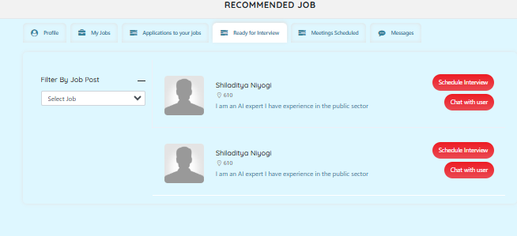
JOB SEEKER
As an employee, I wanted to apply for the two jobs. So I signed in as an employee.
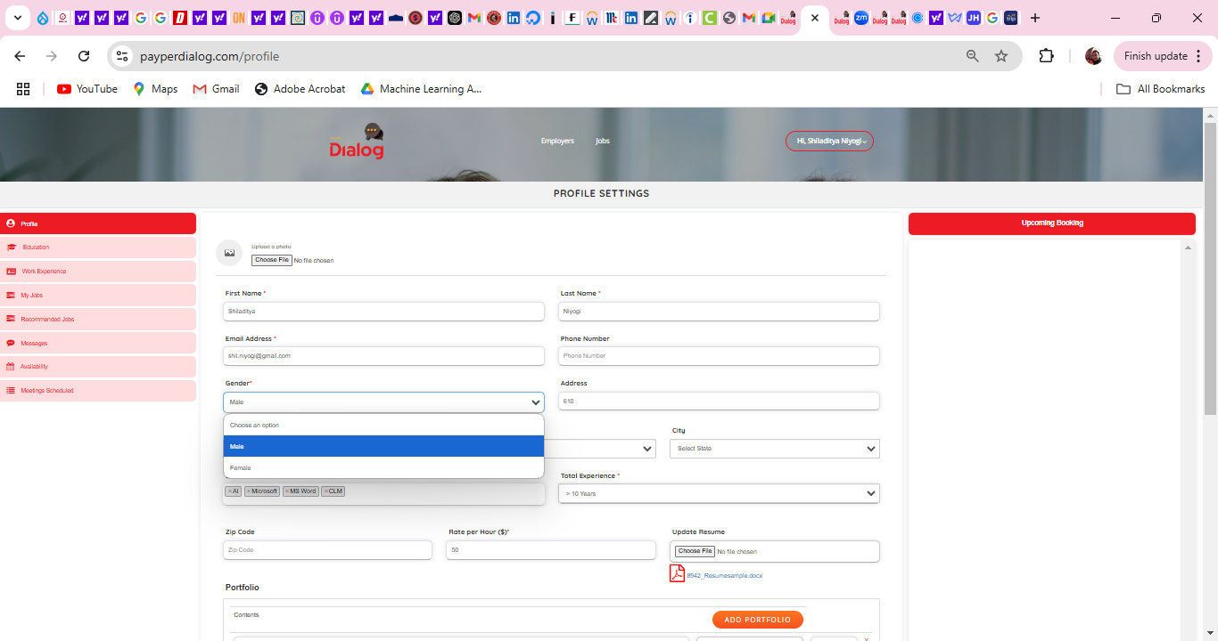
- Can you please add “Non-Binary” after male and female DONE
- Also can we add a self identify tab on the profile and call it out as optional, as some employers want to track this data for record keeping.
  - You can use the form from here - https://www.rfsuny.org/media/rfsuny/documents/careers/Self-ID-Applicants.pdf
- When I sign in I see that a dashboard that is blank. There should be a button for “Dashboard” on the left menu. On this Dashboard page, can we have a few metric type things here – e.g. pointers for profile, pointers for applying for jobs, a square explaining the number of jobs that have been applied to, the number of interviews attended, feedback from interviews received, number of logins, a pointer to the account specifics, etc.
- We have to add another “Account” page to describe the account, what subscription plan that person is on, if they need to add a credit card for payment, changing password option, discontinuing membership, etc. The Dashboard can have a portion dedicated to this account type thing but it is more organized to have a separate page, and that is reflected as an item in the side menu.
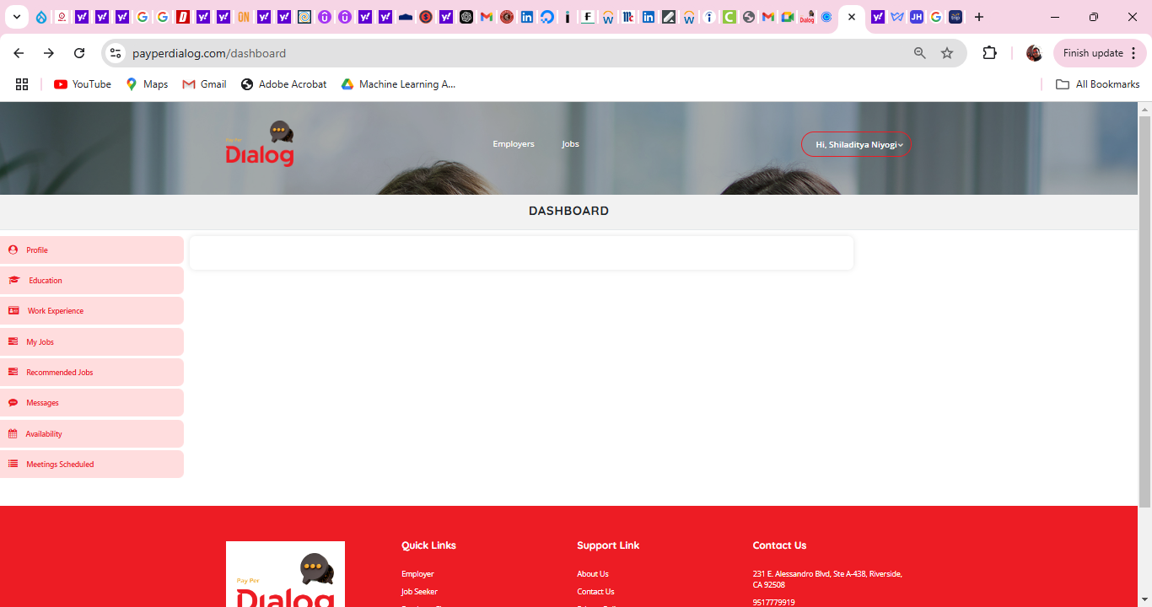
- Change the “upcoming booking” button to “upcoming interview”. “Upcoming interview” section can move to the dashboard page rather than repeating on every page. There should be an “Apply to a Job” button on the side instead, to prompt people to apply fast. DONE
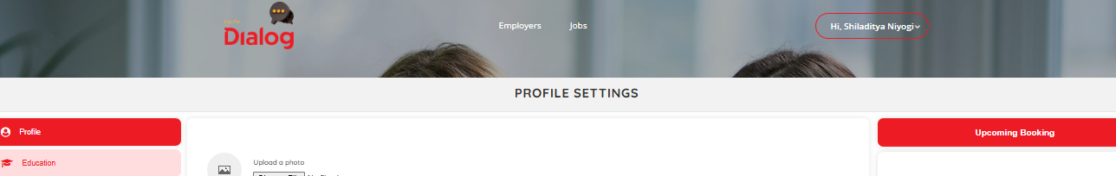
- Also “My jobs” menu title should be changed to “my applications” DONE
- Change “Messages” menu title to “Inbox” and move that to the top of the stack DONE
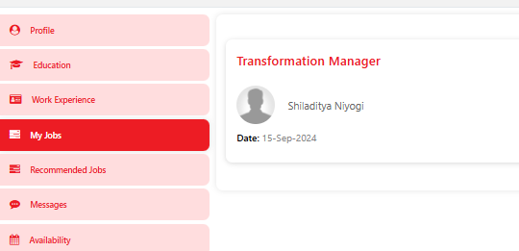

While searching for a job, I am presented with some options. Some questions:
- Noticed that the states inside the state options are not alphabetically ordered. DONE
- The “Date posted” field can have options under “Last Activity”, such as less than a week, etc.
- We can delete last activity field DONE

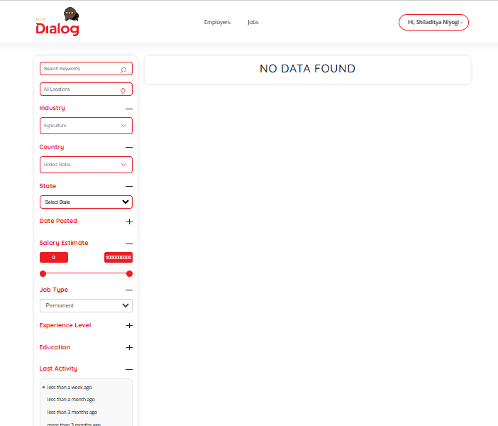
- Under the Education, you can remove “Transfer degree”, Bachelor Degree, Master Degree. DONE
- Rename “Undergraduate Degrees” as Undergraduate Degree”, and “Graduate Degrees” as Graduate Degree”
DONE
- Also, Please check the salary estimate (the higher number can be kept as $1000,000 DONE
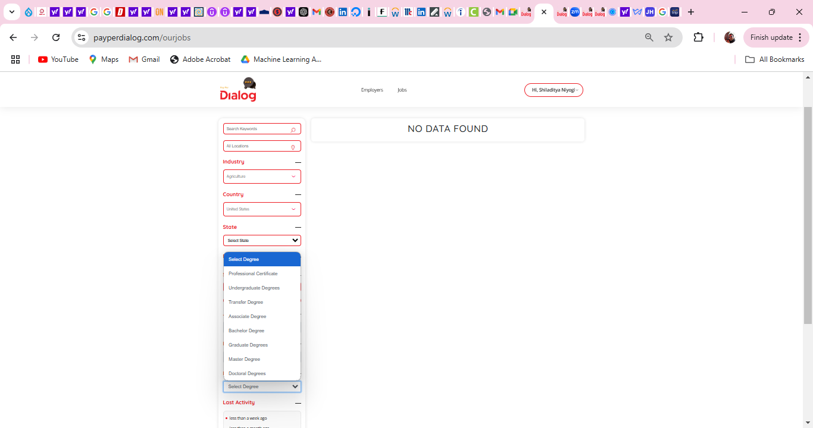

- Also, “apply to a job” can be a button rather than a hyperlink in the banner.
- When I click on the jobs, can we use the phrase “apply” instead of “job details” on the button DONE
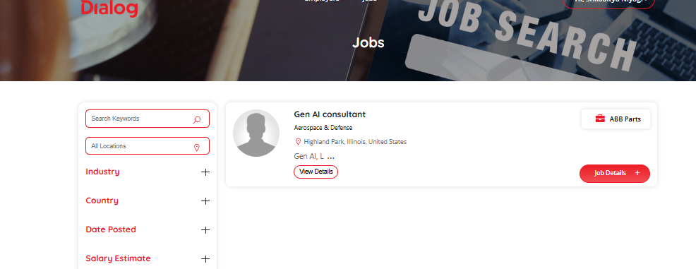
- Also, the job details page should look similar to other pages:
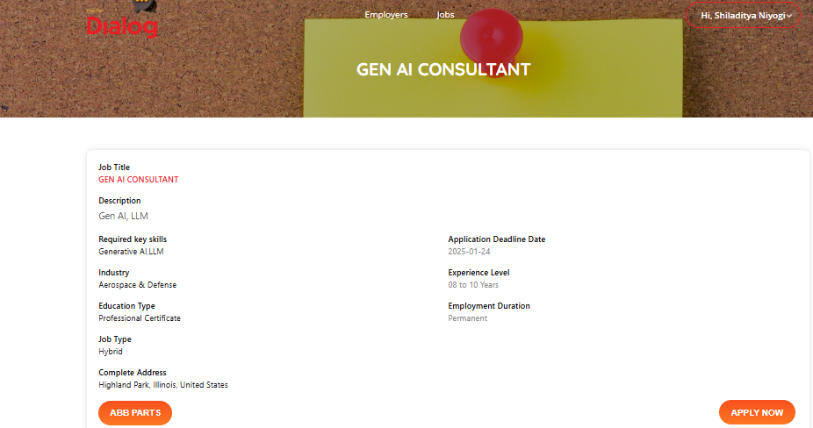
- The name of the company can be a hyperlinked field at the top as well, as opposed to a button at the bottom.

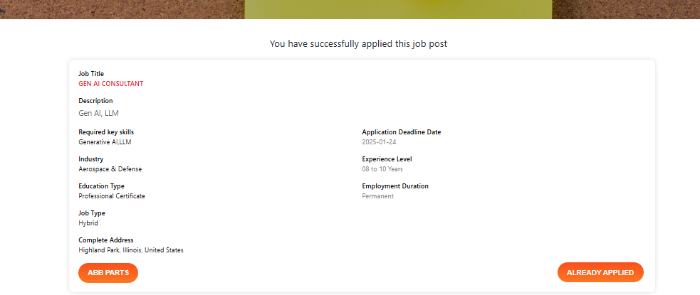
- When I apply, the page again needs to be similar. The page should say “Application successful”. We do not need the “Already Applied” button.

- Also, in the messages tab the search function does not seem to function.
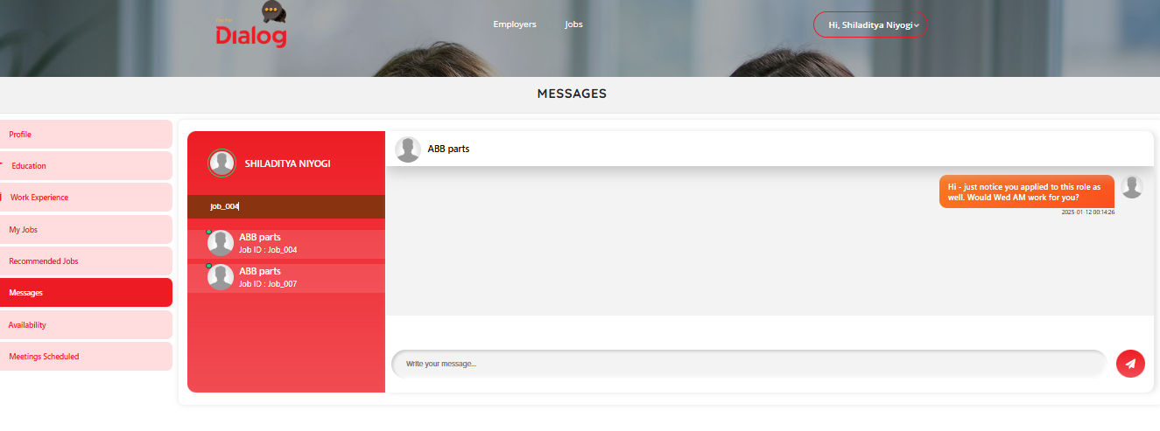
Also,
- If the candidate shares the availability for 5 hours, the employer cannot book a slice – and has to book the whole availability. Also, once selected they cannot change. Can we make them select 30 min slots only and can select multiple such slots for an interview?
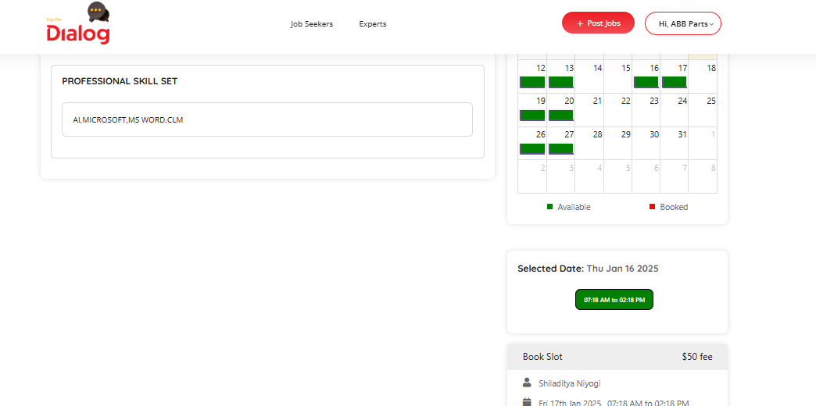
- Also, when I clicked twice, somehow it booked me twice for the same slot.
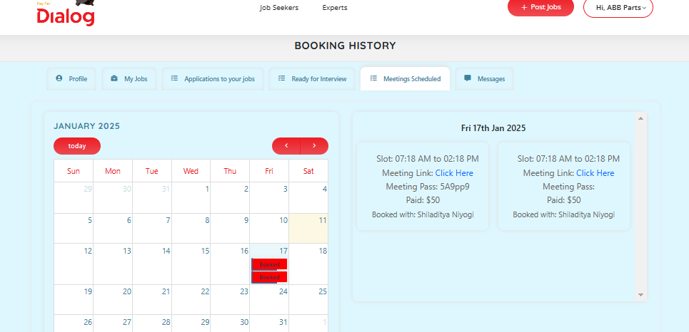
- Can we also indicate the JOB ID or the role in the slots in the meetings scheduled tab? As I was chosen for two interviews how do I know which one to attend when?
- All upcoming interviews should reflect in the job seeker and employer dashboards.
- Also, I did not get an email notification. Can we have a notification sent to email as well as in the inbox (which is what the messages tab will become)?
- How do we change the date if something comes up? When I clicked on another available slot, it didn’t do anything.
The search function needs some clarity.

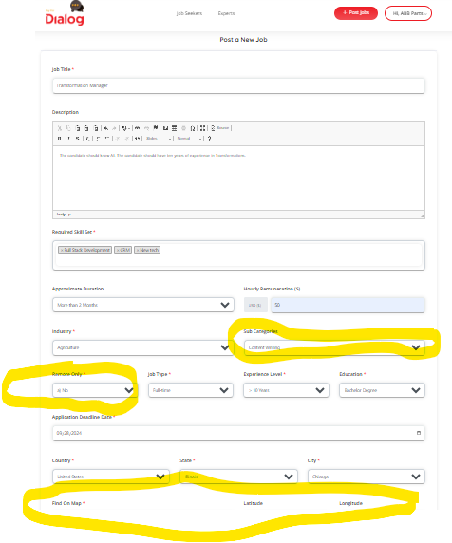
The Find on Map can be optional (It can take City, State, if address is not entered). Do we need to activate google functionality to get the map going? I think I used to see that earlier. Haven’t seen it lately.
Also, for payments, I had a few questions:
- Did you want me to link a bank account, and you will send some money to that account after making the job candidate fee as $1 per hour etc? If I were to connect an account with Paypal and send that over to you, will that be okay?
- In terms of distributing this to the candidate, when you send money do you attribute who gets the money, and what percent of it does pay per dialog gets? How can we change the percentage distribution?
- Also, is there a way to accurately assess the interview time from the Zoom call and use it to pay the money into this account?

